Lab – Explore DNS Traffic

Objectives
Part 1: Capture DNS Traffic
Part 2: Explore DNS Query Traffic
Part 3: Explore DNS Response Traffic

Background / Scenario
Wireshark is an open source packet capture and analysis tool. Wireshark gives a detailed breakdown of the network protocol stack. Wireshark allows you to filter traffic for network troubleshooting, investigate security issues, and analyze network protocols. Because Wireshark allows you to view the packet details, it can be used as a reconnaissance tool for an attacker.
In this lab, you will install Wireshark on a Windows system and use Wireshark to filter for DNS packets and view the details of both DNS query and response packets.

Required Resources
- 1 Windows PC with internet access and Wireshark installed

Instructions
- *always start wireshark first then do all the actions
- *wireshark read bit and translate it to information
- *take the source and find from whatismyip.com (ms use to check scammer IP, hahha)

Capture DNS traffic.
    - Open Wireshark and start a Wireshark capture by double clicking a network interface with traffic.
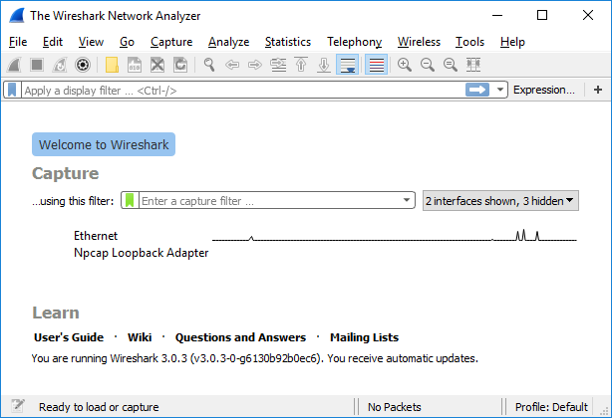
    - At the Command Prompt, enter ipconfig /flushdns clear the DNS cache.
C:\Users\Student> ipconfig /flushdns

Windows IP Configuration

Successfully flushed the DNS Resolver Cache.
    - Enter nslookup at the prompt to enter the nslookup interactive mode.
    - Enter the domain name of a website. The domain name www.cisco.com is used in this example. Enter www.cisco.com at the > prompt.
C:\Users\Student> nslookup
Default Server: UnKnown
Address: 68.105.28.16

> www.cisco.com
Server: UnKnown
Address: 68.105.28.16

Non-authoritative answer:
Name: e2867.dsca.akamaiedge.net
Addresses: 2001:578:28:68d::b33
2001:578:28:685::b33
96.7.79.147
Aliases: www.cisco.com
www.cisco.com.akadns.net
wwwds.cisco.com.edgekey.net
wwwds.cisco.com.edgekey.net.globalredir.akadns.net
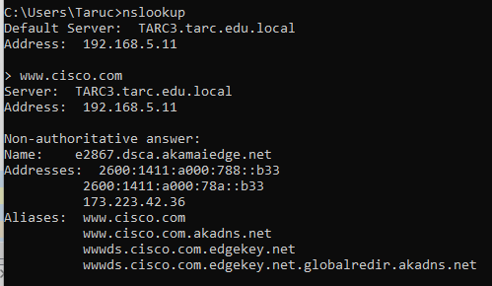
    - Enter exit when finished to exit the nslookup interactive mode. Close the command prompt.
    - Click Stop capturing packets to stop the Wireshark capture.

Explore DNS Query Traffic
    - Observe the traffic captured in the Wireshark Packet List pane. Enter udp.port == 53 in the filter box and click the arrow (or press enter) to display only DNS packets.
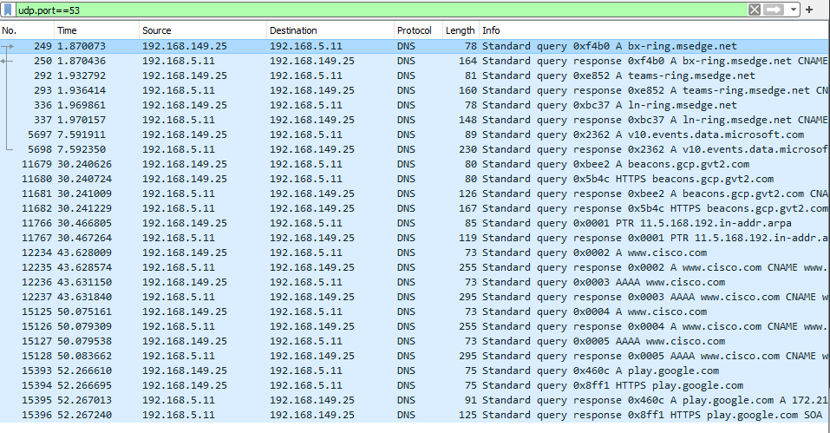
    - Select the DNS packet labeled Standard query 0x0002 A www.cisco.com.
In the Packet Details pane, notice this packet has Ethernet II, Internet Protocol Version 4, User Datagram Protocol and Domain Name System (query).
yx
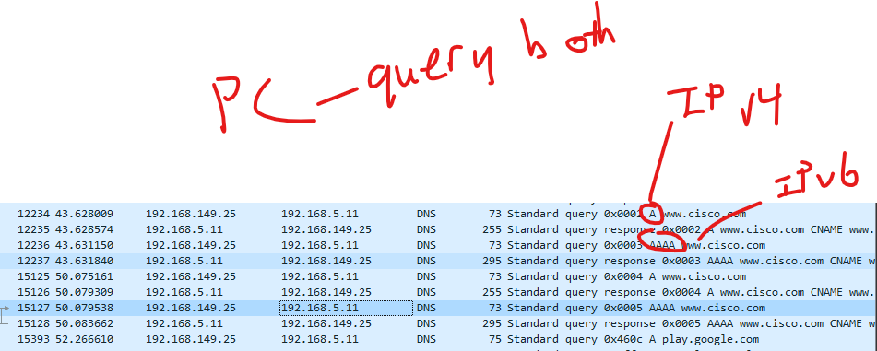
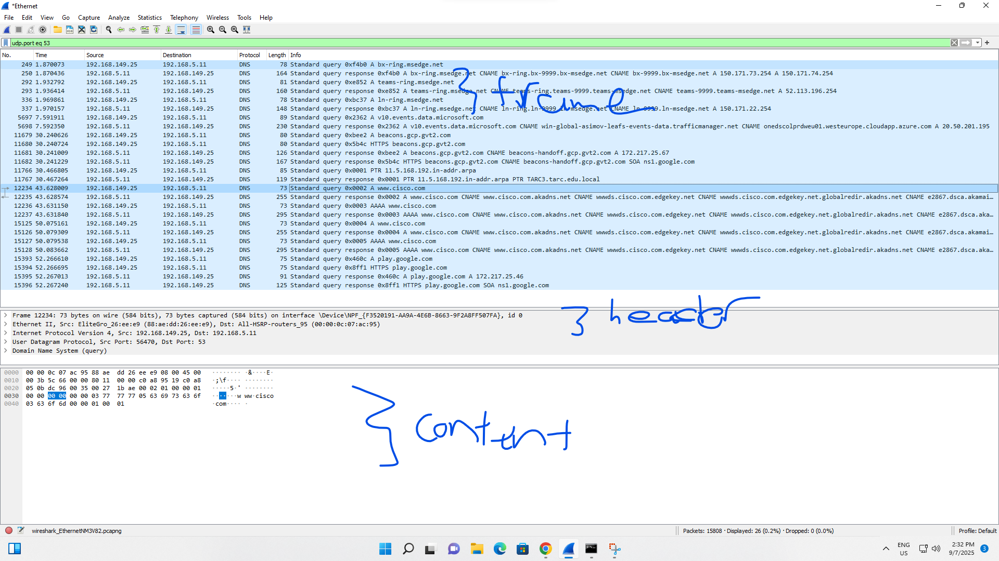
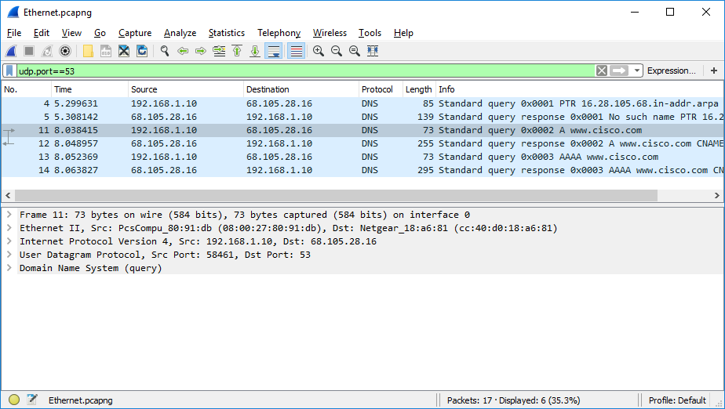
    - Expand Ethernet II to view the details. Observe the source and destination fields.
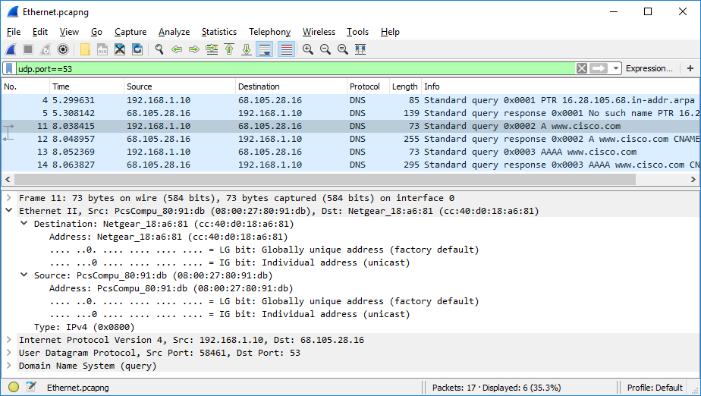
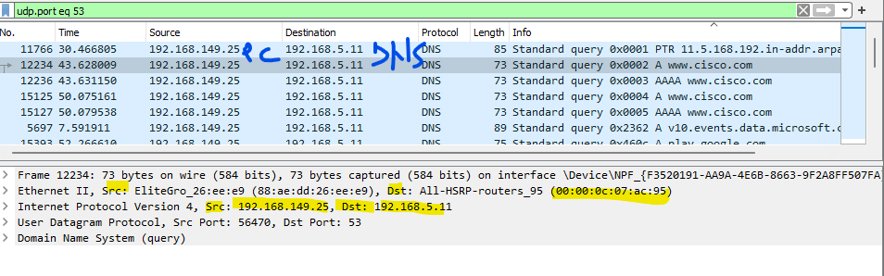

Question:
What are the source and destination MAC addresses? Which network interfaces are these MAC addresses associated with?
MAC address is point to point
source MAC address is my PC
destination MAC address is the next point in the network, my gateway

IP address is end to end
Source IP is my PC's IP
Destination IP is the final end destination which is the DNS server.

Type your answers here.
      - Expand Internet Protocol Version 4. Observe the source and destination IPv4 addresses.
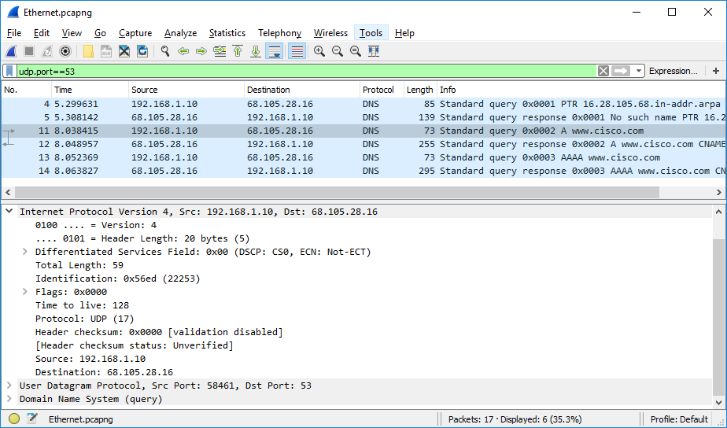

Question:
What are the source and destination IP addresses? Which network interfaces are these IP addresses associated with?
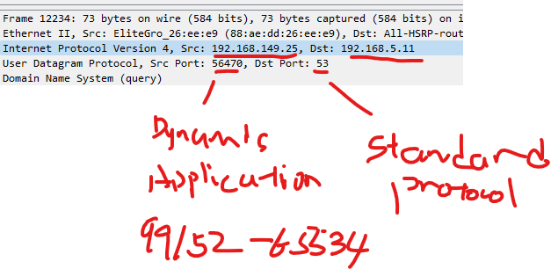
Type your answers here.
      - Expand the User Datagram Protocol. Observe the source and destination ports.
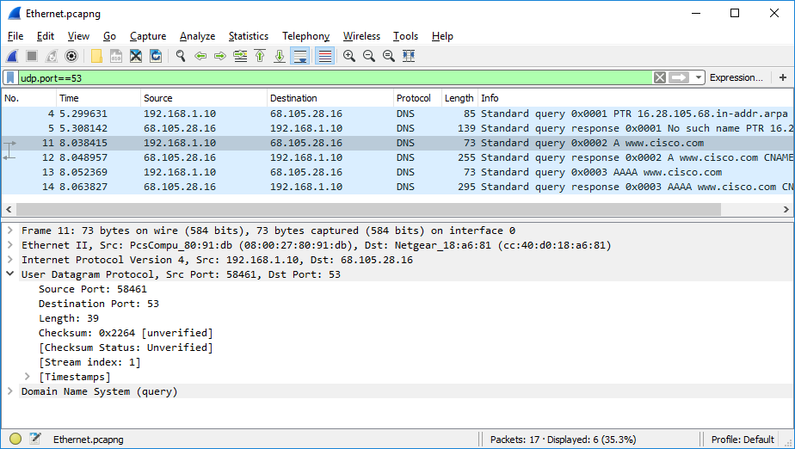

Question:
What are the source and destination ports? What is the default DNS port number?
Type your answers here.
      - Open a Command Prompt and enter arp –a and ipconfig /all to record the MAC and IP addresses of the PC.
C:\Users\Student> arp -a

Interface: 192.168.1.10 --- 0x4
Internet Address Physical Address Type
192.168.1.1 cc-40-d0-18-a6-81 dynamic
192.168.1.122 b0-a7-37-46-70-bb dynamic
192.168.1.255 ff-ff-ff-ff-ff-ff static
224.0.0.22 01-00-5e-00-00-16 static
224.0.0.252 01-00-5e-00-00-fc static
239.255.255.250 01-00-5e-7f-ff-fa static
255.255.255.255 ff-ff-ff-ff-ff-ff static

C:\Users\Studuent> ipconfig /all

Windows IP Configuration

Host Name . . . . . . . . . . . . : DESKTOP
Primary Dns Suffix . . . . . . . :
Node Type . . . . . . . . . . . . : Hybrid
IP Routing Enabled. . . . . . . . : No
WINS Proxy Enabled. . . . . . . . : No

Ethernet adapter Ethernet:

Connection-specific DNS Suffix . :
Description . . . . . . . . . . . : Intel(R) PRO/1000 MT Desktop Adapter
Physical Address. . . . . . . . . : 08-00-27-80-91-DB
DHCP Enabled. . . . . . . . . . . : Yes
Autoconfiguration Enabled . . . . : Yes
Link-local IPv6 Address . . . . . : fe80::d829:6d18:e229:a705%4(Preferred)
IPv4 Address. . . . . . . . . . . : 192.168.1.10(Preferred)
Subnet Mask . . . . . . . . . . . : 255.255.255.0
Lease Obtained. . . . . . . . . . : Tuesday, August 20, 2019 5:39:51 PM
Lease Expires . . . . . . . . . . : Wednesday, August 21, 2019 5:39:50 PM
Default Gateway . . . . . . . . . : 192.168.1.1
DHCP Server . . . . . . . . . . . : 192.168.1.1
DHCPv6 IAID . . . . . . . . . . . : 50855975
DHCPv6 Client DUID. . . . . . . . : 00-01-00-01-24-21-BA-64-08-00-27-80-91-DB
DNS Servers . . . . . . . . . . . : 68.105.28.16
68.105.29.16
NetBIOS over Tcpip. . . . . . . . : Enabled

Question:
Compare the MAC and IP addresses in the Wireshark results to the results from the ipconfig /all results. What is your observation?
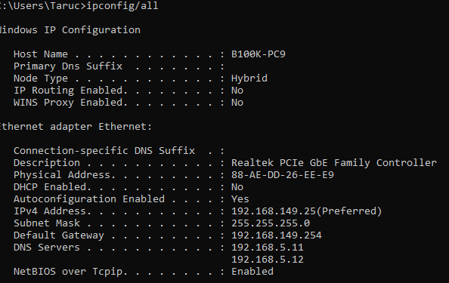
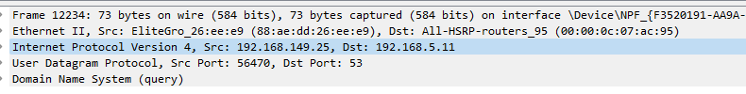
arp
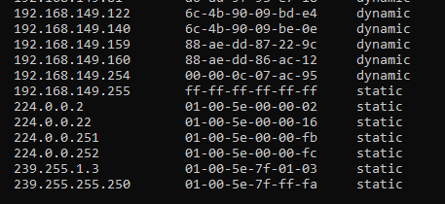
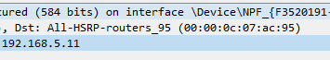

Source IP and MAC address is my own PC
Destination MAC is my gateway MAC address (mac is point to point address)

      - Expand Domain Name System (query) in the Packet Details pane. Then expand the Flags and Queries.
Observe the results. The flag is set to do the query recursively to query for the IP address to www.cisco.com.
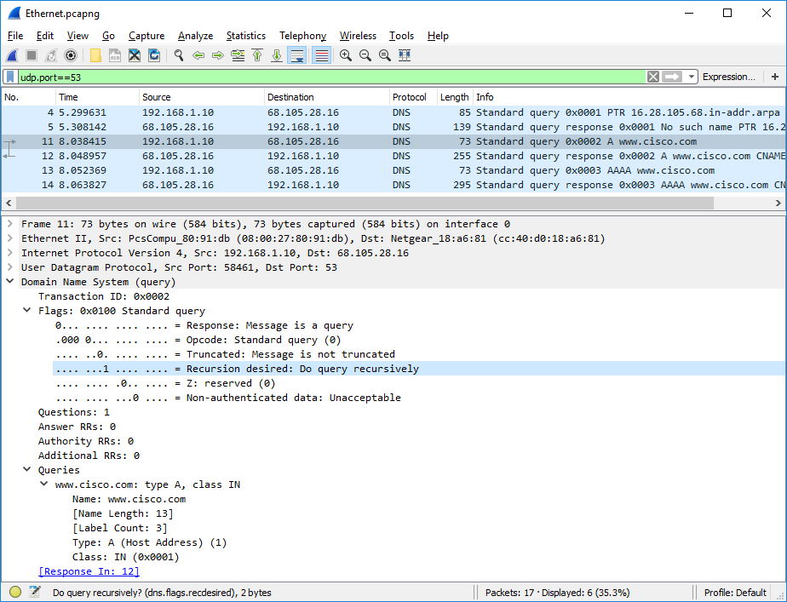

Explore DNS Response Traffic
    - Select the corresponding response DNS packet labeled Standard query response 0x0002 A www.cisco.com.
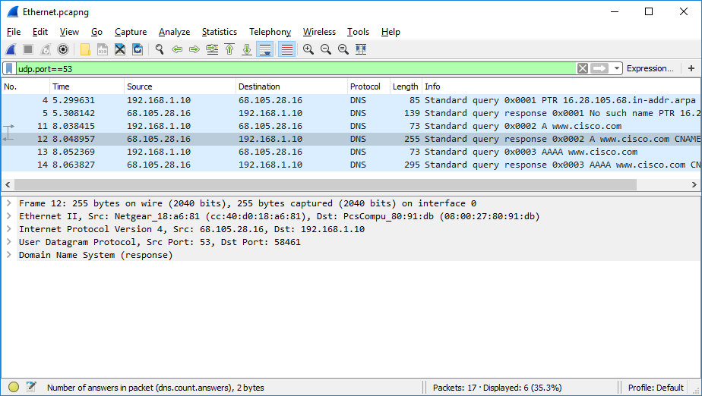

Questions:
What are the source and destination MAC and IP addresses and port numbers? How do they compare to the addresses in the DNS query packets?

Source IP: my PC
Dest IP: DNS Server
Source MAC: My PC
Destination MAC: my gateway
Source port: my pc application dynamic port 56470
destination port: DNS standard protocol port 53

RESPOND PACKET
Source IP: DNS Server
Dest IP: my PC
Source MAC: my gateway
Destination MAC: My PC
Source port: DNS standard protocol port 53
destination port: my pc application dynamic port 56470

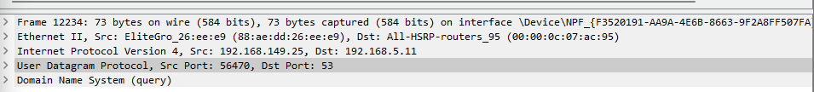
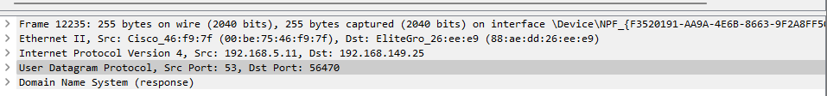
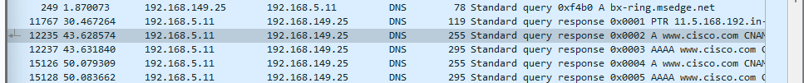

Type your answers here.
    - Expand Domain Name System (response). Then expand the Flags, Queries, and Answers. Observe the results.
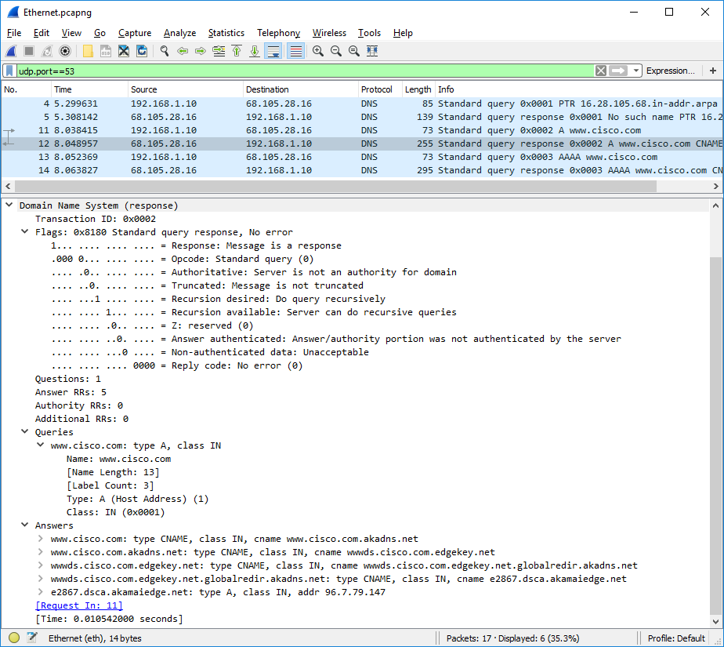

Question:
Can the DNS server do recursive queries?
server can do
Type your answers here.
    - Observe the CNAME and A records in the answers details.

Question:
How do the results compare to nslookup results? Of course same
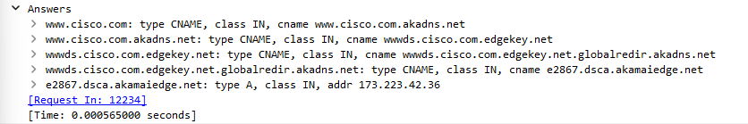
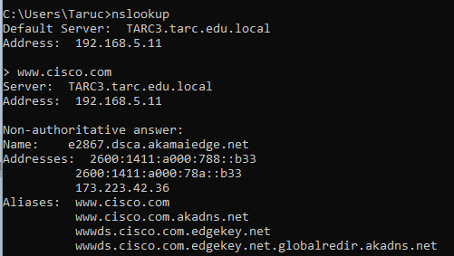
Type your answers here.

Reflection Question
  - From the Wireshark results, what else can you learn about the network when you remove the filter?
- Network have a lots of traffic and packet coming into my network interface card
- There are frames with many protocols
- Many MAC addresses, IP addresses, information of packets.

  - How can an attacker use Wireshark to compromise your network security?
- See all other devices IP
- Guess the IP address and the server / router
- From protocols, DNS packet, DNS server, HTTP packet, web server, …, router ARP reply, guess type of devices, can target which device to attack.

Type your answers here.
End of Document

